ISO CERTIFICATION BODY
K2A MANAGEMENT CO., LTD
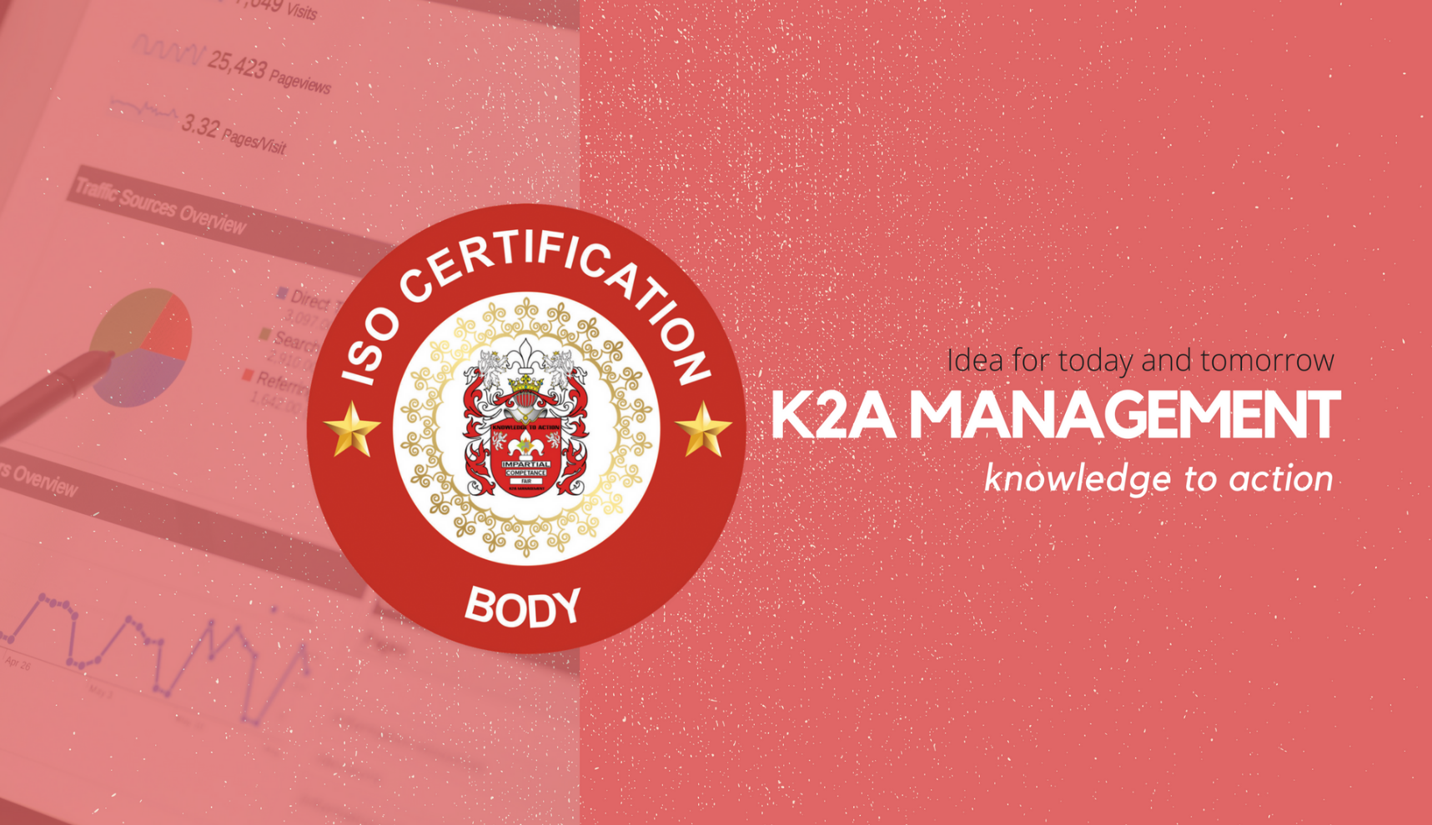
NO Obligation
BEFORE WE CAN PREPARE A WRITTEN ESTIMATE OF COSTS WE NEED CERTAIN INFORMATION ABOUT YOUR ORGANISATION AND STAFF, SO IF YOU WILL PLEASE COMPLETE THE APPLICATION FORM AND RETURN IT TO THE ADDRESS SHOWN ON THE ACCOMPANYING LETTER, WE WILL THEN SUBMIT A QUOTATION TAILORED EXACTLY TO YOUR SITUATION. ALL INFORMATION SUPPLIED WILL BE TREATED WITH STRICT CONFIDENCE.
YOUR APPLICATION DOES NOT COMMIT YOU TO USING OUR SERVICES IN ANY WAY, AND NO APPLICATION FEE WILL BE CHARGED.
APPLICATION
ISO STANDARD CERTIFICATION

Please State Which Certification Registration Do You Require:

ISO 9001:2015 QMS | ISO 14001:2015 EMS |  | ISO/IEC 20000-1:2011Information technology -- Service management | ISO 22000:2018 Food Safety Management Systems
ISO 22301:2012 Business Continuity Management | ISO/IEC 27001:2018 ISMS |  | ISO 28000:2007 security management systems for the supply chain | OHSAS 18001
ISO 45001:2018 OHSMS | OHSAS 13485 QMS Medical Devices |  | ISO/IEC 21000-21:2017 Information technology | ISO 22000 FSSC
ISO 50001 Energy Management | ISO 55001 Asset Management |  | ISO 31000 RISK Management

OTHRES

GMP HACCP GAP BRC HALAL CE Mark RoSH
Please choose your Accreditation Board:

RvA  Dutch Accreditation Council- Raad Voor  European Accreditation Board. |  | CANC  Cambodian Accreditation National Council-Ministry of Industry & Handicrafts
Other | Please Specify
K2A Management is Accredited Body under ISO/IEC 17021 & 17024 and registered with CNAC Cambodian Accreditation National Council under ISO/IEC 17021:2015.
- K2A is Seeking Accreditation under RvA Raad Voor European Accreditation Council under ISO/IEC 17021:2015. Once ISB-K2A will be fully accredited under European Accreditation Council will be able to issue EU and IAF Accredited Certificate.
- K2A Management Also work as Group of CB’s with its associated Partners to provide Accreditation schemes Like UKAS, JAS-ANZ, ULIF

Organization name:
Address:
Country / City:
ZIP Code:
Country:
Telephone:
Web Site:
E-Mail:
Name of Decision Maker
Designation |  |  |  | Direct Line:
Email of Decision Maker | Email:
Total Number of Employees
Total No of Offices
Is your company belonged to a group of Companies | Yes NO
How many total Entities are in Group of companies?
Are you applying for Whole Group? | Yes NO
Name of Entity you wish to certify.
Address & Contact Name:
Do You Use Sub Contractors? (If Yes) Provide the Number of Sub-Contractors involved and their role
Please List the Locations in addition to the Main Head Office
Name of Location/ office |  |  | No of Employees |  | Total No of Shifts
Please provide the details of your business Activity Below:
Have you been Certified Before: (If Yes Please provide Details of the Certification Body and Standard)
Have you appointed the Consultant?
Yes NO
(If Yes Please Provide the details of the consultant)
Name:
Contact Details:
Have you developed your Documented Management System?
Yes NO
(If Yes Please provide the list of documents along with this application

Declaration: The information provided above is true to the best of our knowledge and Belief.
Name: | Title: | Date:

The following section is for K2A Management internal use only. Please do not fill. Thank you.
The applicant’s NACE code is
The information about the applicant organization and its management system is sufficient to develop an audit program |  |  | Yes No
Any known difference between in understanding between K2A and the applicant organization is resolved |  |  | Yes No
K2A Management has the competence and ability to perform the certification audit |  |  | Yes No
The scope of certification, the site, the time required and other relevant elements have been taken into consideration |  |  | Yes No
The minimum number of audit days is:
Stage 1: |  | Stage 2:
Surveillance Audit Days
Audit assigned to:

Approver:

